**Project Design Phase-II**

**Data Flow Diagram & User Stories**

|  |  |
| --- | --- |
| Date | 12 April 2025 |
| Team ID | SWTID1743519439 |
| Project Name | BookNest |
| Maximum Marks | 4 Marks |

**Data Flow Diagrams:**

DFD Level 0

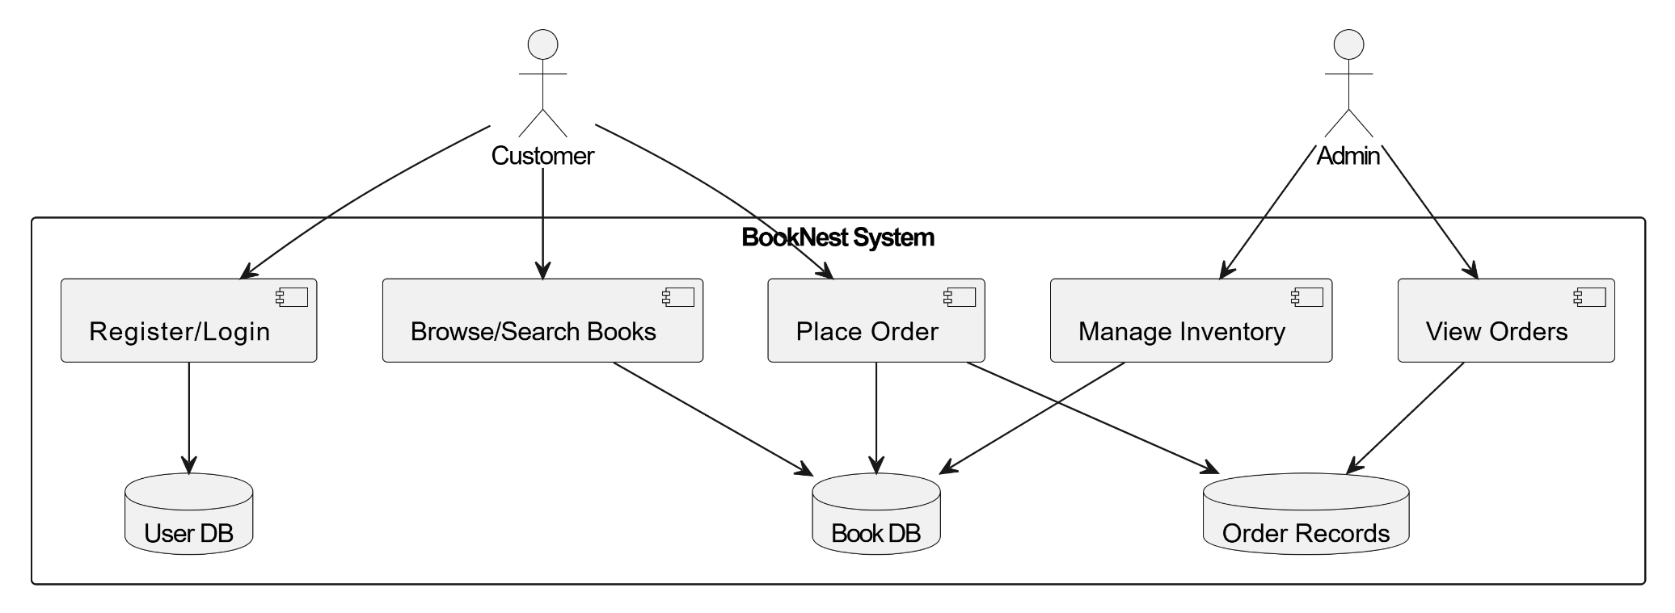

**DFD level 1**

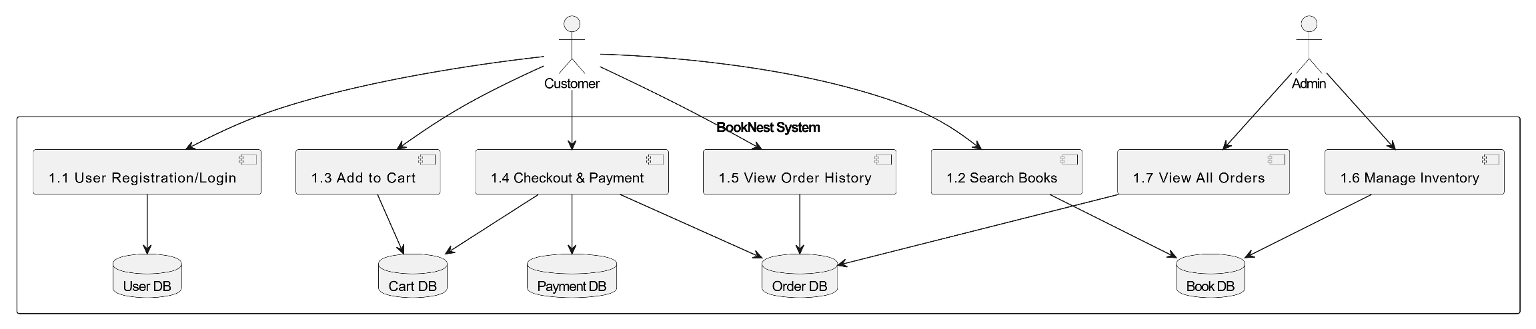

**User Stories**

| **User Type** | **Functional Requirement (Epic)** | **User Story Number** | **User Story / Task** | **Acceptance Criteria** | **Priority** | **Release** |
| --- | --- | --- | --- | --- | --- | --- |
| Customer (Web) | Registration | USN-1 | As a user, I can register with email and password. | I can access my account after successful registration. | High | Sprint-1 |
| Customer (Web) | Registration | USN-2 | As a user, I receive a confirmation email after registering. | I can confirm my email by clicking the link. | High | Sprint-1 |
| Customer (Web) | Login | USN-3 | As a user, I can login with valid credentials. | I can access my dashboard. | High | Sprint-1 |
| Customer (Web) | Browse/Search Books | USN-4 | As a user, I can browse and search for books by title or author. | I can view relevant book listings. | High | Sprint-1 |
| Customer (Web) | Cart & Checkout | USN-5 | As a user, I can add books to cart and proceed to checkout. | I can place an order. | High | Sprint-2 |
| Customer (Web) | Order History | USN-6 | As a user, I can view my previous orders. | I can see a list of past orders. | Medium | Sprint-2 |
| Admin | Manage Inventory | USN-7 | As an admin, I can add, update, or delete books from inventory. | I can maintain the catalog. | High | Sprint-1 |
| Admin | Manage Users | USN-8 | As an admin, I can view and manage registered users. | I can access and modify user information. | Medium | Sprint-2 |
| Admin | View Orders | USN-9 | As an admin, I can view all orders placed by users. | I can track all sales and order records. | High | Sprint-2 |